Q #1) What is Cloud Computing? State some advantages.
Answer: Cloud Computing is all about the delivery of on-demand computing services. These services are divided into three categories – Platform-as-a-service(PaaS), Infrastructure-as-a-service(IaaS) and Software-as-a-service(SaaS).
The hallmark of these services is innovation at a faster rate and flexibility in the available resources. The advantages of Cloud Computing are:
- Security
- Less expensive
- Enhance Collaboration
- Offer Flexibility
- Provide Insights
- Automated Software Updates
- 24 x 7 Availability
Security
Cloud Computing helps to store all the enterprise sensitive data in its system and this can be accessible, even if your computer is down. The security is offered by encrypted data – transmitted over the network and stored in a database.
Less Expensive
Since less cost is incurred due to hardware in Cloud Computing, the services offered are bound to save costs for your enterprise. It allows you to pay per your operational requirements, adopting a subscription plan.
Enhance Collaboration
Cloud Computing simplifies the process of collaboration and enables your employees to work as a team. It increases the engagement of your people with collaborative social spaces.
Offer Flexibility
If there is an increasing demand for bandwidth, then Cloud offers almost instant service, without any need to undergo a complex update to your IT infrastructure. The cloud increases the flexibility in the service compared to a local server hosting.
Provide Insights
You can obtain a different perspective of your data with an integrated Cloud Analytics. Cloud-based services make it simpler to track and generate customized reports -based on enterprise-wide data.
Automated Software Updates
Cloud Computing applications automatically update the software, with no need for your organization to undergo a manual update. This saves money to a considerable extent.
Availability (24 x 7)
The Cloud-based service providers provide a 24 x 7 service. It is possible to access the services, from anywhere and they are highly reliable. It is possible to offer some of the services, offline.
Q #2) What are the differences between Private and Public Cloud?
Answer: Public Cloud is offered across the globe by sharing hardware, storage and network devices with various organizations. These organizations are termed as cloud tenants.
Private cloud is limited for an organization, with infrastructure and services are maintained on the private network for an organization or any business entity. It allows the organization to meet the demands of specific business requirements – with customization of private resources.
Q #3) Can you differentiate between Hybrid Cloud and Public Cloud?
Answer: Hybrid Cloud brings out the best of both the worlds – public and private clouds. This way the hybrid cloud offers a range of deployment options and enhances flexibility.
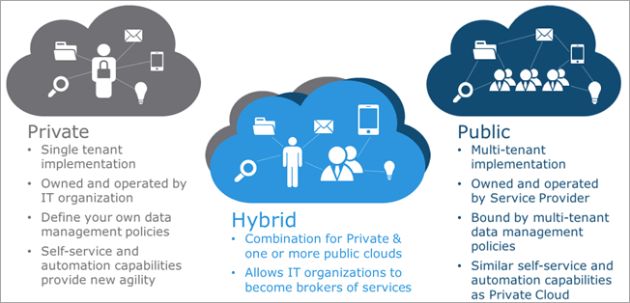
Cloud bursting is another option when the organization transitions from a private cloud to a public cloud – managing an increase in demand, during seasonal activities such as online shopping.
However, in the case of a public cloud the resources are shared with other organizations too. Here the account is managed and services accessed – using a web browser.
Q #4) What is Page Layout in Salesforce? What are the Record Types?
Answer: Page Layout is about the control of fields, buttons, Visualforce, custom links and s-control on the Salesforce object record pages. This enables the user to customize the record pages.
It helps to determine the nature of fields – read-only, visible or required. Here is the look of the page layout:
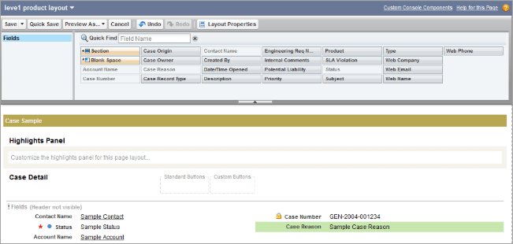
For example: Create custom fields for an account object say last recharge amount, membership expiry date and membership plan and then create various page layouts with these fields. To know more please watch the video:
On the other hand, record types are most convenient to offer different subsets of picklist values or page layouts for the users. These are based on user profiles. They determine which page layout is visible to a user, based on the user profile. Please see the example of a Record Type below:
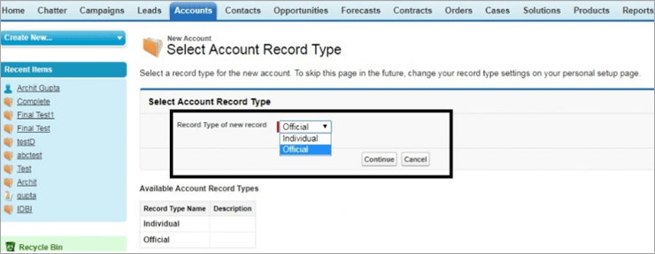
For Example, Use Picklist values for segmentation of your business needs with record types. The segmentation is done based on region, product line or division.
Q #5) What are the types of portals in Salesforce?
Answer: There are three types of Salesforce portals and these are:
- Customer
- Partner
- Self-service
Q #6) What is a Workflow? What all are its components? What is a Workflow Rule?
Answer: Workflow allows you to automate the standard processes and procedures for your organization and saves a considerable amount of your time. The workflow comprises of an if/then statement.
The two major components of the workflow are:
- Criteria: This is the “if” part of the statement. You need to set a criterion for a workflow rule. Create a workflow rule for an object and then configure the criteria.
- Action: This is the “then” part of the statement. This tells you what to do once the criteria are met and comes after the configuration of a workflow rule. It is possible to add an immediate action or a time-dependent action for a specific workflow rule.
A workflow rule in Salesforce acts as a business logic engine or a container and take some automated actions based on some criteria. It executes the action only when the criteria are True, otherwise, the record is saved. Here is a figure that shows a workflow rule.
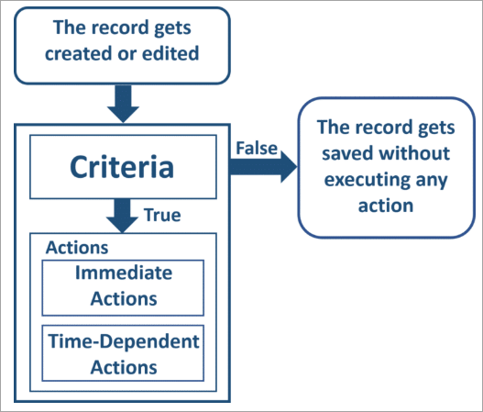
Q #7) What is the Time-Dependent Workflow?
Answer: Time-dependent actions are performed at specific times before the record is closed. The record is re-evaluated by the workflow rule after the time elapses. It checks as to whether the workflow rule criteria are met and only then actions are executed by the workflow rule.
Q #8) How to clear the Time-Based Workflow Action Queue?
Answer: There are two ways to clear the time-based workflow action queue and these are:
- Remove the scheduled actions of the queue.
- The criteria are turned false.
Q #9) If an Action is scheduled to be executed for a Time-Based Workflow, is it possible to delete the Workflow?
Answer: No, it is not possible to delete the workflow in such a scenario, when there is some existing time-based action to be completed.
Q #10) In how many ways can you call Apex Classes?
Answer: The many ways to call Apex classes are:
- From Visualforce Page
- Within another Class
- Invoke from a Trigger
- Use a Developer Button
- Use JavaScript buttons and Links
- From Components in a Home Page
Q #11) What are the different Workflow Actions?
Answer: The various Workflow Actions are:
- Email alerts
- Outbound messages
- Field Update
Q #12) What is a Workflow Task? State the various Workflow Tasks in Salesforce.
Answer: When you need to assign tasks to a Salesforce user you resort to a Workflow Task. It assigns a new task to a user, record owner or a role. It helps to specify various parameters of the task such as subject, priority, status and due date.
For Example, Assign follow-up tasks to a support person, after some time elapses for an updated case.
Q #13) What is a Workflow Alert?
Answer: This is an email created by a workflow rule or an approval process in Salesforce and sent across to various recipients.
Q #14) If you want to set the Running User other than yourself in the dashboard then what is the permission required?
Answer: Here the permission required is “View All Data” to set another running user in the dashboard.
Q #15) How do users see Report Headers while scrolling? What to do to enable this Floating Report Header?
Answer: The parameter “Floating Report Header” is enabled to freeze the report header, so that it appears always on the top of a page, despite scrolling of records.
When you want to enable a floating report header, you need to follow the path as stated below:
- From Setup-> Enter Reports in Quick Find box
- Select Reports and Dashboards Settings.
- Select Enable Floating Report Headers.
- Click Save.
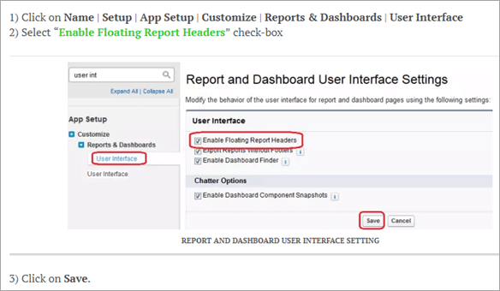
Q #16) Is it possible to schedule a Dynamic Dashboard?
Answer: No, it is not possible to schedule a dynamic dashboard for a refresh. This is only possible when done manually.
Q #17) Who are the people who can access a “drag and drop dashboard”?
Answer: It is possible to access the drag and drop dashboard with users who have the “manage dashboard” permissions.
Q #18) How to run a Salesforce Report?
Answer: All that needs to be done is to click on ‘Run Report” and thus run a report automatically in Salesforce.
Q #19) Can you name the Data Management Tools in Salesforce?
Answer: The data management tools used in Salesforce are:
- Data Loader
- Data Import Wizard
Q #20) Can you tell me about Data Import Wizard?
Answer: Data Import Wizard in Salesforce makes it easier to import standard objects like accounts, leads, contacts, person accounts, and others. It enables us to import custom objects too. The number of records allowed to be imported is 50,000. Here is an image depicting Data Import Wizard:
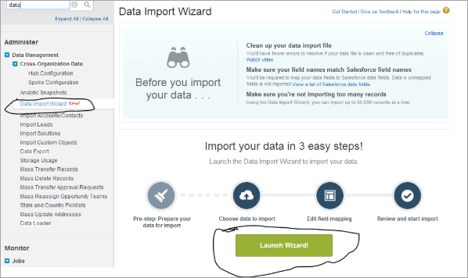
Q #21) Can you tell me about Export and Export All with reference to Data Loader?
Answer: Export and Export All are the two buttons present in the Salesforce Data Loader. When the export button is used with any Salesforce object, then all the records belonging to that particular object (except the ones present in the recycle bin) are exported to a .csv file.
In the case of Export All option, all records for that object including the ones from the recycle bin are exported to a .csv file.
Q #22) Can the Data Loader delete the reports?
Answer: The Data Loader cannot delete reports in Salesforce.
Q #23) State what are Custom Reports in Salesforce? What are Custom Report Types?
Answer: Custom Reports in Salesforce are built as per the requirements of your organization. These reports can be built on standard and custom objects.
When the user is keen to create a complex, dynamic report quickly then he/she uses a template or framework to specify the object/relationship or the fields that make the report.
Q #24) What are the Matrix and Trend Report?
Answer: Matrix Reports are similar to a summary report but both rows and columns are grouped in it. Here data appears as in Excel sheets – both vertical and horizontal. Here is a diagram for a matrix report:
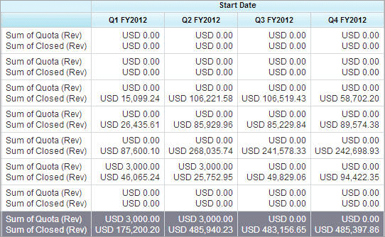
[image source]
On the other hand, trend reports are based on historical data. Here you can consider the fields that contain historical data and which can be left out. Here are some details on a Trend Report.
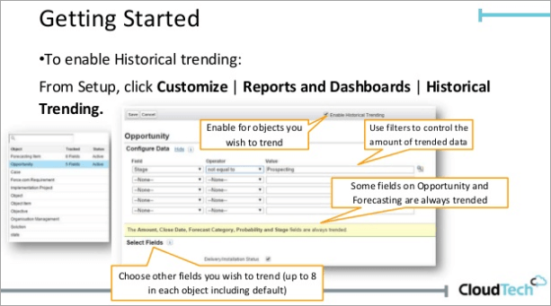
Q #25) State what is Roll-up Summary Field?
Answer: Roll-up summary field is used for calculating values for related records say, a related list. It can be used to create value for a master record – based on the value in those of the detail records. However, the detail and the master must be connected with a master-detail relation.
For example: If there is a custom account field called Total Invoice Amount then this can be used to display the total of all related custom invoice records for the Invoice related list of the account.
Q #26) Is it possible to change/modify the Child Record Settings of a Master-Detail Relationship, for setting Owd (Organization-Wide Settings)?
Answer: No, the child record settings cannot be changed for a master-detail relationship, applicable for an Owd.
Q #27) State the cause of error for insufficient privilege access in a Partner Community with External Users. The User has proper Owd and Profile Settings for any object.
Answer: We need to check the following to determine this error so that the external user must have access to all the data for the internal user.
- Check field-level security for all fields for the external users – used in the reports.
- Check as to whether the Standard Visibility Record Settings are enabled. If enabled then only the user can view all the standard report types.
Q #28) What are Sharing Rules? Name what are the types of sharing Rules?
Answer: The sharing rule provides sharing access to users belonging to roles, public groups or territories. It provides a greater level of access with automatic exceptions, away from your organization-wide settings. Here is a figure that explains:
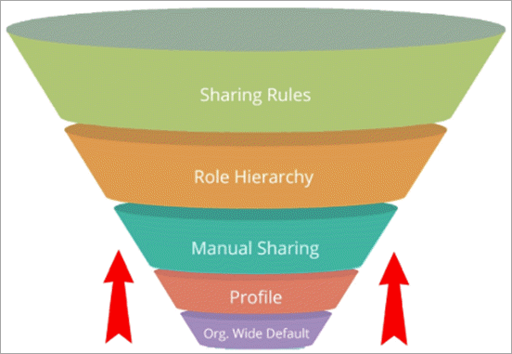
[image source]
The two types of sharing rules are:
- Owner-based sharing rules
- Criteria-based sharing rules
Owner-based Sharing Rules: Access is given for records owned by other users.
For Example, The Sales Head of a US company giving access to the Sales Manager in the European region to opportunities owned by the US team.
Criteria-based Sharing Rules: Access is given based on record values and not based on record owners. It states who do you share records based on the field value.
For Example,There is a custom picklist value called the department for a custom object in your organization named job application. A criteria-based sharing rule allows the IT manager to see all job applications for the department field set as “IT”.
Q #29) What do you think are the best practices of creating Contact Sharing Rules?
Answer: The permissions for the read, read/write, write are used by using the default settings across the entire organization.
Q #30) What do you mean by Login Hours and Login IP Ranges?
Answer: The first parameter sets the hours when the user of a specific profile can use the system. This can be set by the following path:
The second parameter sets the IP addresses for the users of a particular profile login into Salesforce otherwise they are denied access. This is set by the following path:
Q #31) What is Field-Level Security? How do you set Field-Level Security on a single field for all profiles?
Answer: This is a setting that comes in handy for restricting the view and edit of certain fields by the Salesforce users. For setting field-level security for a specific field but all profiles, navigate to the following path:
Management Settings of a field object> Select the field in the field area-> View Field Accessibility->Specify the access level of the field.
For details please visit- Salesforce
Q #32) What is a Standard Profile?
Answer: Standard profiles are used in every Salesforce org and enable editing of settings. However, in some organizations where it is not possible to create a custom profile, as in Contact Manager and Groups Editions, the users can be assigned with standard profiles but unable to view or edit them.
Q #33) State what are User Permissions in Salesforce?
Answer: The tasks performed by the Salesforce users as well as the accessible features are the functions of the user permissions. These user permissions are enabled by custom profiles and permission sets.
For Example, There is user permission “View Setup and Configuration” and the user can access the Setup pages in Salesforce with this.
Q #34) What are the Permission Sets in Salesforce?
Answer: The Salesforce users can access various functions and tools with a collection of settings as well as permissions. Although the permission sets are also available in the user profiles when there is a need to access functional aspects then the permission sets are used, with no need to change the profile, whatsoever.
Here is a figure that explains Permission Sets:
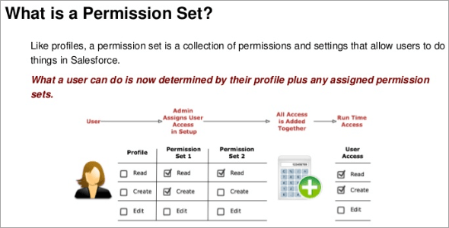
Q #35) Which fields are indexed by default in Salesforce?
Answer: The default indexed fields in Salesforce are:
- Primary Keys (ID, owner and name fields)
- Foreign Keys (lookup and master-detail relationship)
- Audit Dates
- Custom Fields (only marked as External ID or unique)
Q #36) When to use indexed fields in Salesforce?
Answer: Indexed fields can be used in query filters and this serves the purpose of optimization of query retrieval time and thus quickly fetches the records.
Q #37) What is “transfer record” in Profile?
Answer: Transfer record permission when given to a user allows the user to transfer all records with the read access.
Q #38) What is conditional highlighting in Salesforce Reports? State some limitations.
Answer: When you need to highlight field values in matrix or summary reports with the use of ranges or colours then conditional highlighting is used. But, one thing is important for you to remember that the report must have at least one summary field or custom summary formula. This is shown in the below figure:
For example:
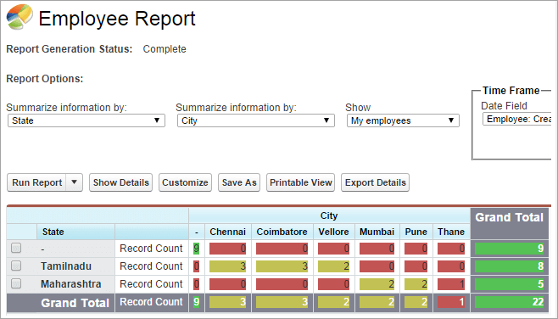
[image source]
The limitations of conditional highlighting are:
- Only applied to summary rows.
- Only for summary and matrix reports.
- Use a maximum of up to three conditions in a report.
- Use only for summary rows.
Q #39) How to automate business processes?
Answer: Salesforce used various tools such as approvals, workflow, process builder and flow builder to automate business processes.
Q #40) What is Approval Process? Are automated actions supported by Approval Processes? How many?
Answer: Approvals comprise of a sequence of steps for approval of records in Salesforce. The approval process specifies how records are approved in Salesforce. It elaborates on details such as the person from whom the approval request arises and what all is done at every step.
Yes, four types of automated actions are supported by the approval process.
Q #41) What are Queues in Salesforce?
Answer: Queues in Salesforce help to prioritize, distribute as well as assign records to teams sharing workloads. They apply to cases, service contracts, leads, orders, custom objects and many such more.
It becomes possible for the queue members to jump and take ownership of any record that is in the queue. To know more, watch this video on Salesforce Queues:
For example: Create a queue on a case for support agents assigned to various service levels.
Q #42) Can you throw some light on Assignment Rules? How do you Set up an Assignment rule?
Answer: Assignment rules impose conditions on the processing of cases or leads. You can set up and assignment rule by following the path:
Go to Setup->Search for Assignment Rules in Quick Find Box-> Choose Lead/Case Assignment Rule->Click New-> Save after a name->Create Rule entries.
For details please visit- Salesforce
Q #43) What are Custom Labels in Salesforce? How to access custom labels? What is the character limit for Custom Labels?
Answer: Custom Labels help to create a multilingual application in Salesforce. They provide information automatically to the users in the form of error messages and help texts – by using their native language.
Custom Labels are defined as custom text values to be accessed from a Visualforce page or an Apex class or even Lightning components. These values then are translated into any language that is supported by Salesforce. You can access the custom labels with the below path:
Setup->Search Custom Labels in Quick Find Box->Custom Labels
It is possible to create 5000 custom labels for your organization and the character limit is 1000.
Q #44) What is Auto-Response?
Answer: This is about sending automatic emails to cases or leads for specified record attributes. Quickly reply to customer issues or inquiries by setting up an auto-response rule. At a time, it is possible to set one rule for a case and one for a lead.
Here is how an auto-response rule looks like for two levels of support in an organization (Basic and Premier) and two products (A and B). For a premier support customer, with a case, the premier template is sent from the corresponding Premier Support email address.
On the other hand, the basic support customer will receive a different template.
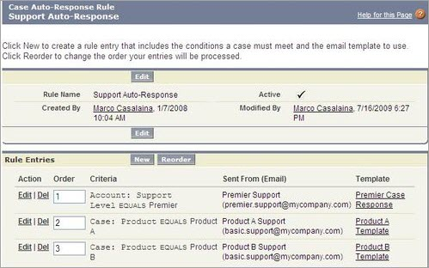
Q #45) What are Escalation Rules?
Answer: These rules apply to the escalation of cases as per the criteria defined in the escalation rule entry. Along with the rule entries, it is possible to create escalation actions to specify what happens when a case escalates. An escalation rule can reassign the case to another support agent or even a support queue.
Q #46) What are the uses of Salesforce Chatter?
Answer: Chatter is the Salesforce’s enterprise social networking application that allows users to share information, working collaboratively and conversing with each other. It helps to build higher employee engagement by motivation.
It also provides a forum across the enterprise to share insights or novel ideas. You can use the mobile feed to track your team for a critical project for a mobile-first experience. Here a figure on how it looks like:
